Exercise 4

# Job Provider - jobs list ,remove, add

### **Job List screen:**

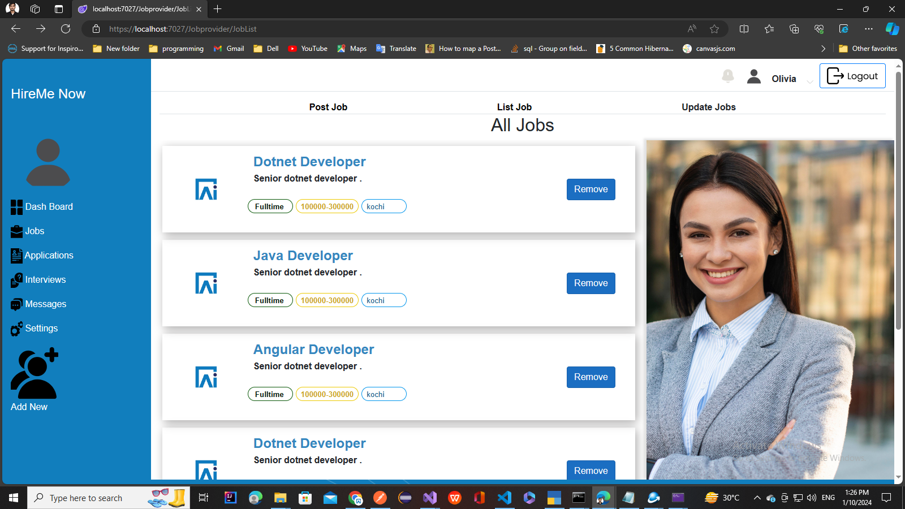

### **Add Job Screen:**

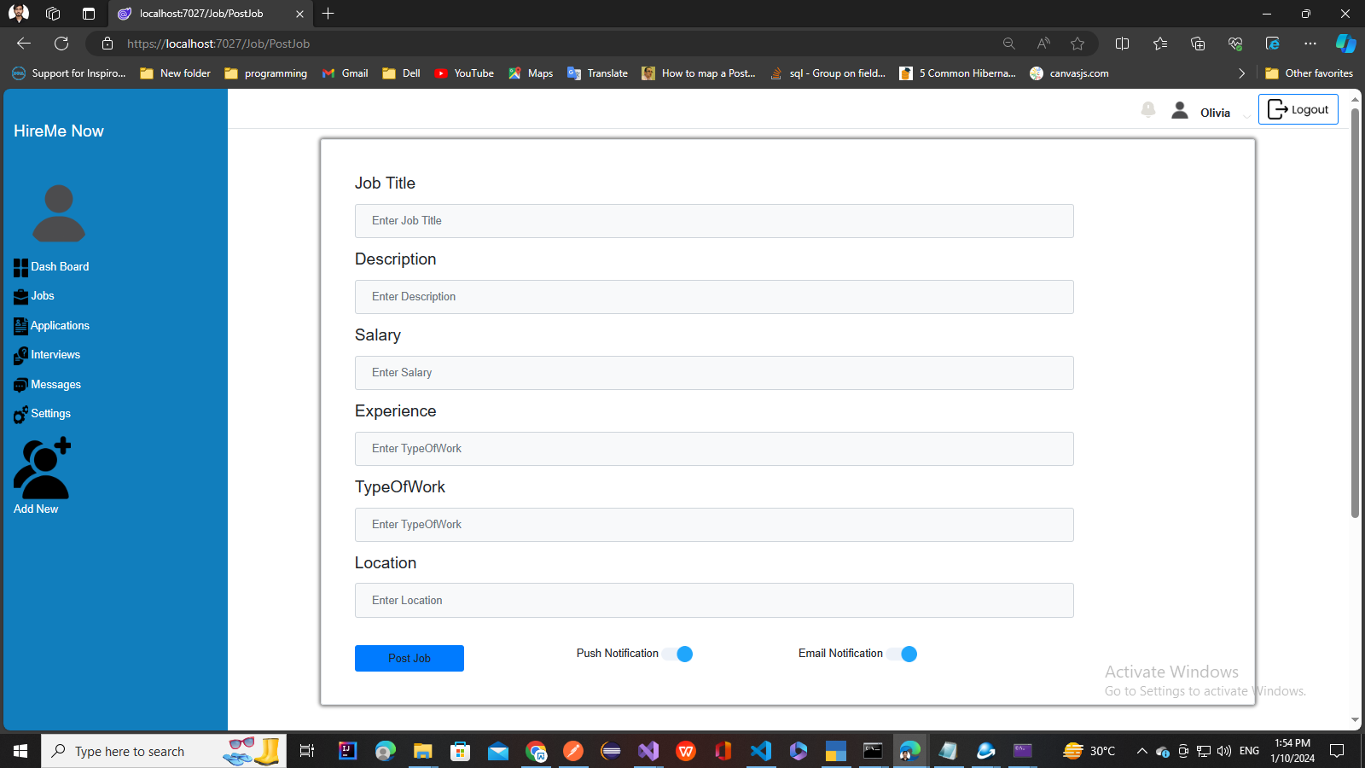

**Features to implement:**

* Create Job List page to List Jobs from a list of jobs
* Create Add Job Component to add job
* Implement the Create job functionality to add jobs to the list